Section A
- There are three states of matter.

- In the boxes below, sketch particle diagrams for the three states of matter.

Solid Liquid Gas
- Which state of matter has the highest density?

___________________________________________________________________________________
- Use your particle diagrams to explain why.

___________________________________________________________________________________

___________________________________________________________________________________
- Which is the correct equation to calculate density?

Tick (✓) one box.

Density = mass x volume | 
Density = mass
volume
Density = volume
mass
- Density can be measured in kg/m³. Which of these is another unit that could be used to measure density?

Tick (✓) one box.

g/cm
cm/g³
g/cm³

Section B
- The graph below gives the density of several types of rock.

- Which type of rock would contain the most particles in a 1 cm³ sample?

____________________________________________________________________________________

- What type of graph is this?

____________________________________________________________________________________

- Why is this type of graph suitable?

____________________________________________________________________________________
____________________________________________________________________________________

- A scientist has a sample of sandstone with a mass of 0.011 kg. What is this mass in grams?

____________________________________________________________________________________

- The sample of sandstone has a volume of 5 cm³. Calculate the density of the sandstone.

____________________________________________________________________________________
____________________________________________________________________________________
- Add this value to the graph above.

- Calculate the volume of a 1.375 g piece of granite, using information from the graph.

____________________________________________________________________________________
____________________________________________________________________________________

- Calculate the mass of this block of slate, using information from the diagram and the graph.
6 cm
_________________________________________________
4 cm
10 cm
_________________________________________________
_________________________________________________
_________________________________________________

- Helium-filled balloons float in air. Explain what this shows about the relative densities of air and helium and their particle arrangements.

____________________________________________________________________________________
____________________________________________________________________________________
____________________________________________________________________________________
____________________________________________________________________________________

Section C

- Water is a useful substance to demonstrate changes of state because its melting and boiling points can be achieved in the lab.
- State what water is called when it exists as each different state of matter.
- State the melting and boiling points of water.
- Describe what happens to the particles when water changes from liquid to solid.
- Define internal energy.
- In which state of matter do particles have the most internal energy.
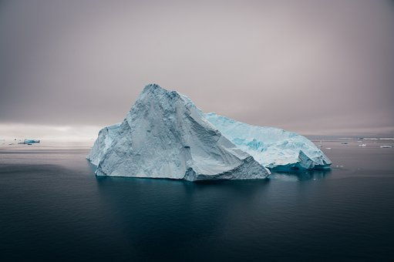
- Describe what happens to internal energy when a substance melts from a solid to liquid.
- An iceberg has a volume of 35 m³ and a mass of 32 000 kg. Calculate the density of the iceberg.
- Explain why the iceberg floats on water.
- The iceberg will eventually melt. Explain why.

